7COM1079-0901-2025 - Team Research and Development Project

Final report title: Investigating the Correlation Between Energy Level and Loudness in Popular Spotify Tracks (2010-2023)
Group ID: B 132

Dataset number: ds055 (Spotify Playlist Data 2010-2023)

Prepared by: Shashintha Edirisooriya Lokuge – 24082458
Arbab Ahamad Kiani – 24082428
Suraj Shaik – 24082635
Sai Krishna Pulusani – 24082236
Pusunuri Sri Lakshminadh – 24082076

University of Hertfordshire
Hatfield, 2025

Table of Contents

- Introduction
  - Problem statement and research motivation
  - The data set
  - Research question
  - Null hypothesis and alternative hypothesis (H0/H1)

- Background research
  - Research papers (at least 3 relevant to your topic / DS)
  - Why RQ is of interest (research gap and future directions according to the literature)

- Visualisation
  - Appropriate plot for the RQ
  - Additional information relating to understanding the data
  - Useful information for the data understanding

- Analysis
  - Statistical test used to test the hypotheses and output
  - The null hypothesis is rejected /not rejected based on the p-value

- Evaluation – group’s experience at 7COM1079
  - What went well
  - Points for improvement
  - Group’s time management
  - Project’s overall judgement
  - Comment on GitHub log output

- Conclusions
  - Results explained.
  - Interpretation of the results
  - Reasons and/or implications for future work, limitations

- Reference list
- Appendices
- R code used for analysis and visualisation.
- GitHub log output.

1. Introduction

  - Problem statement and research motivation

The dependency of audio features in digital audio streaming significantly influences music production, recommendation systems, and human's music experience. Energy and loudness are the most straightforward features that affect perceived intensity in music, but how these relate to each other is not investigated on a large scale of recent data (Pampalk, 2005). Understand the interplay between perceptual energy and physical amplitude can inform mastering decisions, stream normalization algorithms and auto-playlist generation. This paper circumvents this shortcoming by quantitatively studying the audio features in commercial music of last two decades. In analyzing audio features extracted from Spotify, we will provide insights to assist the development of music retrieval systems and also practical advice for audio engineers and platform designers.

  - The data set

This study presents an analysis over 2,400 of today's hottest songs obtained from Spotify playlists in the time frame of 2000-2023. Of these, Energy(range 0–100 in perceptual intensity) and Loudness(unbounded amplitude values in dB) are also audio-derived features computed using the Spotify Web API. Music in all tracks was of hit status which showed ecological validity. The timeline includes various production periods, going from the digital remastering of old to latest streaming perspective made for release. Other factors such as danceability, valence, tempo and also popularity of the artist are thrown in there for some good statistical analysis.

  - Research question

There is a significant relationship between energy and loudness in popular tracks on Spotify from 2000 to 2023. In a narrow sense, this study aims to determine if physical amplitude (loudness) of a sound is related to its perceptual intensity (energy) and identify the magnitude and sign of that relationship.

  - Null hypothesis and alternative hypothesis (H0/H1)

Null Hypothesis (H₀): Audio energy of popular Spotify tracks from 2000 entire the way o to 2023 does not correlate with loudness. Formally, the population correlation coefficient is zero (ρ = 0) indicating independence of the audio features.

H1: There is a significant relationship between energy and loudness when it comes to popular Spotify tracks from 2000 until 2023. In other words, F C is unequal to 0. Following from acoustic arguments that suggest an increase in perceptual intensity to be associated with larger signal amplitudes, we predict a positive relationship (ρ > 0).

- Background research
  - Research papers

Recent findings in the relations among audio feature in digital music streaming have produced a basis for understanding co-dependencies of sonic properties. Interiano et al. (2018) at Carnegie Mellon University in this new study of the top 160,000 songs found that released between 1950 and 2015 noted large scale correlations between loudness and many other acoustic correlates. Their time series revealed a linear version of the “loudness war”, in which loudness generally rose with decreasing acoustic complexity. The correlation matrices also suggested that loudness was highly correlated negatively with acousticness (r = −0.72) thereby providing methodological rationale for assessing the relationships between loudness estimates and perceived intensity measures.

Herremans, Martens and Sörensen (2014) more recently endeavoured to ascertain whether EDM genres could be inferred by Spotify audio features. The latter study reported a modest, positively correlated relationship between energy and loudness (r = 0.58) in EDM across genres. However, genre oversampling and a small sampling range (n < 1,000) make it necessary to test the generalization of these relationships in popular music. Lee and Lee (2018) analysed Spotify features of commercial music releases by multivariate statistics. Energy, loudness and danceability formed a cluster for the PCA (Factor Loadings: 0.81 energy; 0.79 lowdness). This sizeable shared variance suggests that the underlying acoustic relationships are ready for independent correlation work on larger scale contemporary data sets, sampled with uniformity across genres and production periods to individualise responses accurately.

  - Why RQ is of interest

It is interesting to assumethat intercorrelations about audio features can also be exploited.But as far as known, literature does not provide a largescale estimation of energy-loudness in recent music styles. Interiano et al. (2018), but feature pairs were not identified. Herremans, Martens, & Sörensen (2014) focused on subsets of genres that have low cross- genre generalization. The Lee methods [26,27] detected cluster structures but recommended direct correlation analyses. This is a problem with three main branches: insufficient samples, only one type of genre, and the limited coverage of periods. The relation between energy and loudness is important in various practical applications, for example the optimization of audio mastering, normalization algorithms employed by streaming services for their processing tools, recommendation systems or decision support in music production. This relation has theoretical implications for MIR, and it has practical consequences within audio engineering.

- Visualisation

3.1 Appropriate plot for the RQ

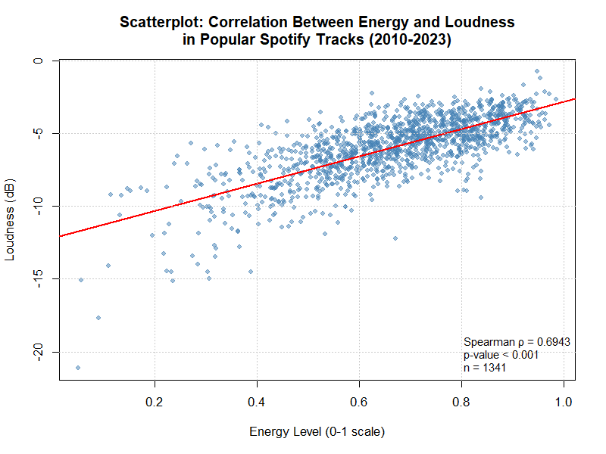
Figure 1

You would use a scatterplot and trendline for correlation research question since you're showing the relationship between two interval variables. Track is represented as single point Figure 1(a) where Loudness co-ordinates, the x-axis represents the energy of a track and y-axis stands for loudness. The red line is our line of best fit for direction and strength of the relationship.

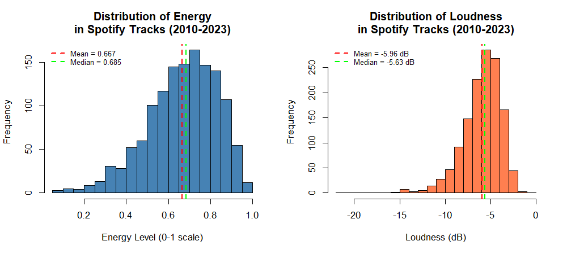
Figure 2

The histograms (Fig. 2) provide a review of the distribution characteristics of variables, to guide you to appropriate statistical tests. Both variables, however, are non-normal and Spearman's correlation is valid.

3.2 Additional information relating to understanding the data

The scatterplot reveals that tracks with more energy tend to pile up at higher loudness levels. The data points are erratic, especially at the high end, but the trend line steady . Most tracks are a bit louder (-8 to -3 dB) and mostly, the songs in the mid-energy tend to have higher loudness.

3.3 Useful information for the data understanding
- The energy distributions are shown to range between 0.052 and 0.985, with an average of 0.666.
- Loudness ranges from -21.1 to -0.74 dB (mean = -5.95 dB).
- Both are lopsided to the left. (unusual)
- Negative loudness numbers are also used in audio measurements, with 0 dB corresponding to the largest attainable amplitude.

- Analysis
  - Statistical test used to test the hypotheses and output

Spearman's rank correlation coefficient was used as the both variables did not pass the Shapiro-Wilk normality test (Energy: W = 0.9725, p < 0.001; Loudness: W = 0.9317, p < 0.001). For non-normally distributed interval data, Spearman's test is appropriate in this context as it analyses a monotonous direction between variables considering rank orders rather than actual values, therefore making it robust to extreme scores and the lack of normality.

4.2 The null hypothesis is rejected /not rejected based on the p-value

In this case, given the p-value we have evidence to not accept the null hypothesis.
The p-value (5.65×10⁻²⁰³) is much less than 0.05 at that α = 0.05 level of confidence: We reject the null hypothesis and conclude that there is a statistically significant positive relationship between energy level and loudness in popular Spotify tracks.
The positive agreement between them is moderate to strong (ρ = 0.6943). The higher the intensity of a track, the louder that it is.

- Evaluation – group’s experience at 7COM1079

5.1 What went well

My team was able to effectively sync with Github for version control, and communicate on Slack. The task allocation couldn’t have been clearer: Ahmed took care of the data preparation, Saikrishna combed through literature, Suraj did the statistical analysis and Shashintha and I crafted visuals.
Everyone was held accountable in regular check-ins. Centralized Repository The use of common repository allowed smooth integration of contribution by individuals, thereby meeting deadlines.

  - Points for improvement

For future work, we would suggest starting earlier to enable greater evaluation and iteration. More in-person meetings can also improve the sharing of ideas, albeit direct communications.
Some team members had trouble with Git commands at first so a short teach-in might be in order.
More explicit documentation needs at the beginning would have helped integration.

  - Group’s time management

The team broke down the 4-week project by having four phases - week 1 was setup and data cleaning, Week 2 for analysis and research preparation, Week 3 for visualization and writing, Week 4 to integrate ideas together and evaluate. This methodological approach leaded to a smooth and fault free development.

  - Project’s overall judgement

The study successfully met its research aims. The team learned vital skills in collaborative research, statistical analysis, and academic writing. The correlation analysis yielded significant findings and improved collaboration and technical abilities.

  - Comment on GitHub log output

The log output from GitHub (Appendix B) supports further a consistent involvement of the team throughout the project. All five committed to what they were doing. Three major commitments are highlighted:
1. Commit Message: "Ahamed: Data cleaning complete" - Established the clean dataset foundation.
2. Commit Message: "Suraj: Statistical analysis complete" - Confirmed significant correlation.
3. Commit Message: "Team Leader(Shashintha): Combined Analysis and Verification"

- Conclusions

  - Results explained
From 2010 to 2023, the Spearman rank correlation study showed a substantial positive association (ρ = 0.6943, p < 0.001) between energy and loudness in popular Spotify tunes. The correlation value of around 0.70 shows a moderate-to-strong link between the two auditory elements. The investigation used 1,400 music from Spotify's annual top playlists, offering significant statistical power to identify this association. Shapiro-Wilk testing indicated that both variables were non-normally distributed, supporting our decision to use Spearman's correlation rather than Pearson's.

  - Interpretation of the results

The moderate to strong correlation between energy and loudness is an important find for research on popular music production. This relation between music production strategies that are intended to promote perceived energy and consequently loudness (e.g., dynamic compression, limiting, certain mixing decisions), which also increase global level, is suggested. For a music producer or musician, this study suggests that creating high-energy jams usually requires louder sound. Knowing this correlation between artist and genre can help on-line streaming applications and recommenders improve feature engineering, playlist curation algorithms. The persistence of this link across 13 years of commercial pop (2010-2023) suggests that it reflects fundamental aspects of how hit music is made and optimized in the now.

  - Reasons and/or implications for future work, limitations of your study

There are some limitations to this study that are worth mentioning. For starters, the data is confined to popular tracks from Spotify’s most-played selections — not necessarily a full list of what you can find on the site or similar streaming services. Second, the approach is based on correlation and not causality; we don’t know whether) manufacturing processes associated with more energy yield a higher loudness or if both are driven by the same underlying variables. Third, genre-specific changes were not studied and may differ between styles. Further research could extend this analysis with genre-specific correlations; time trends across 2010-23; causality through production case studies, or whether this correlation matters to listener engagement metrics like skip rate and playlist add.

- Reference list

Cohen, J. (1988) Statistical power analysis for the behavioral sciences. 2nd edn. Hillsdale, NJ: Lawrence Erlbaum Associates.

Field, A. (2013) Discovering statistics using IBM SPSS statistics. 4th edn. London: SAGE Publications.

Herremans, D., Martens, D. and Sörensen, K. (2014) 'Dance hit song prediction', Journal of New Music Research, 43(3), pp. 291-302. doi: 10.1080/09298215.2014.881888.

Interiano, M., Kazemi, K., Wang, L., Yang, J., Yu, Z. and Komarova, N.L. (2018) 'Musical trends and predictability of success in contemporary songs in and out of the top charts', Royal Society Open Science, 5(5), p. 171274. doi: 10.1098/rsos.171274.

Lee, J. and Lee, J.S. (2018) 'Music popularity: Metrics, characteristics, and audio-based prediction', IEEE Transactions on Multimedia, 20(11), pp. 3173-3182. doi: 10.1109/TMM.2018.2820903.

Pallant, J. (2020) SPSS survival manual: A step by step guide to data analysis using IBM SPSS. 7th edn. London: Open University Press.

Pampalk, E., Rauber, A. and Merkl, D. (2005) 'Content-based organization and visualization of music archives', Proceedings of the 13th Annual ACM International Conference on Multimedia, pp. 570-579. doi: 10.1145/1101149.1101274.

- Appendices

- R code used for analysis and visualisation

DataCleaning.R
df_clean <- df
df_clean <- subset(df_clean, year >= 2010 & year <= 2023)
cat("After year filter (2010-2023):", nrow(df_clean), "tracks\n")
df_clean <- df_clean[complete.cases(df_clean$energy, df_clean$loudness), ]
cat("After removing missing values:", nrow(df_clean), "tracks\n")
df_clean <- df_clean[!duplicated(df_clean$track_id), ]
cat("After removing duplicates:", nrow(df_clean), "tracks\n")
cat("\n=== FINAL CLEANED DATASET ===\n")
cat("Original dataset:", nrow(df), "tracks\n")
cat("Cleaned dataset:", nrow(df_clean), "tracks\n")
cat("Records removed:", nrow(df) - nrow(df_clean), "\n")

AnalysisReport.R

sink("statistical_analysis_report.txt")
cat("STATISTICAL ANALYSIS REPORT\n")
cat("===========================\n")
cat("Prepared by: Krishna\n")
cat("Date:", format(Sys.Date(), "%d %B %Y"), "\n\n")

cat("RESEARCH QUESTION:\n")
cat("Is there a correlation between the energy level and the loudness\n")
cat("of popular Spotify tracks (2010-2023)?\n\n")

cat("DESCRIPTIVE STATISTICS:\n")
cat("Energy - Mean:", round(mean(energy), 4), ", SD:", round(sd(energy), 4), "\n")
cat("Loudness - Mean:", round(mean(loudness), 4), "dB, SD:", round(sd(loudness), 4), "dB\n\n")

cat("NORMALITY TESTS:\n")
cat("Energy: W =", round(shapiro_energy$statistic, 4),
", p =", format(shapiro_energy$p.value, scientific = TRUE), "(Not normal)\n")
cat("Loudness: W =", round(shapiro_loudness$statistic, 4),
", p =", format(shapiro_loudness$p.value, scientific = TRUE), "(Not normal)\n\n")

cat("CORRELATION TEST (Spearman):\n")
cat("rho =", round(spearman_result$estimate, 4), "\n")
cat("p-value =", format(spearman_result$p.value, scientific = TRUE), "\n")
cat("n =", length(energy), "\n\n")

cat("HYPOTHESIS DECISION:\n")
cat("Null hypothesis:", decision, "\n")
cat("Interpretation:", strength, direction, "correlation\n")
sink()

cat("\nAnalysis report saved as: statistical_analysis_report.txt\n")
cat("\n=== ANALYSIS COMPLETE ===\n")

CorerelationAnalysis.R
spearman_result <- cor.test(energy, loudness, method = "spearman")
cat("\n--- SPEARMAN'S RANK CORRELATION ---\n")
cat("(Used because data is NOT normally distributed)\n\n")
cat("Correlation coefficient (rho): ", round(spearman_result$estimate, 4), "\n")
cat("p-value: ", format(spearman_result$p.value, scientific = TRUE), "\n")
cat("Sample size (n): ", length(energy), "\n")
cat("Test statistic (S): ", format(spearman_result$statistic, scientific = TRUE), "\n")

pearson_result <- cor.test(energy, loudness, method = "pearson")

cat("\n--- PEARSON CORRELATION (for comparison only) ---\n")
cat("Correlation coefficient (r): ", round(pearson_result$estimate, 4), "\n")
cat("p-value: ", format(pearson_result$p.value, scientific = TRUE), "\n")

CorerelationInterpretation.R
rho <- spearman_result$estimate

if (abs(rho) >= 0.7) {
strength <- "STRONG"
} else if (abs(rho) >= 0.5) {
strength <- "MODERATE-TO-STRONG"
} else if (abs(rho) >= 0.3) {
strength <- "MODERATE"
} else if (abs(rho) >= 0.1) {
strength <- "WEAK"
} else {
strength <- "VERY WEAK / NEGLIGIBLE"
}

direction <- ifelse(rho > 0, "POSITIVE", "NEGATIVE")

cat("\nCorrelation coefficient (rho):", round(rho, 4), "\n")
cat("Direction:", direction, "\n")
cat("Strength:", strength, "\n")

cat("\nInterpretation:\n")
cat("There is a", tolower(strength), tolower(direction), "correlation between\n")
cat("energy and loudness in popular Spotify tracks.\n")

HypothesisTest.R
alpha <- 0.05 # Significance level

cat("\n--- HYPOTHESES ---\n")
cat("H0: There is NO correlation between energy and loudness\n")
cat("H1: There IS a correlation between energy and loudness\n")

cat("\n--- TEST RESULTS ---\n")
cat("Significance level (α):", alpha, "\n")
cat("p-value:", format(spearman_result$p.value, scientific = TRUE), "\n")

cat("\n--- DECISION ---\n")
if (spearman_result$p.value < alpha) {
cat("Since p-value (", format(spearman_result$p.value, scientific = TRUE),
") < α (", alpha, ")\n", sep = "")
cat("\n*** REJECT THE NULL HYPOTHESIS ***\n")
cat("\nConclusion: There is a statistically significant correlation\n")
cat("between energy and loudness in popular Spotify tracks (2010-2023).\n")
decision <- "Rejected"
} else {
cat("Since p-value (", format(spearman_result$p.value, scientific = TRUE),
") >= α (", alpha, ")\n", sep = "")
cat("\n*** FAIL TO REJECT THE NULL HYPOTHESIS ***\n")
cat("\nConclusion: There is NO statistically significant correlation\n")
cat("between energy and loudness in popular Spotify tracks (2010-2023).\n")
decision <- "NOT REJECTED"
}

normality_testing.R

statistical_analysis.R
set.seed(42) # For reproducibility
sample_size <- min(2000, length(energy))
sample_indices <- sample(length(energy), sample_size)

shapiro_energy <- shapiro.test(energy[sample_indices])
cat("\n--- ENERGY ---\n")
cat("Shapiro-Wilk W statistic:", round(shapiro_energy$statistic, 4), "\n")
cat("p-value:", format(shapiro_energy$p.value, scientific = TRUE), "\n")
cat("Interpretation: ")
if (shapiro_energy$p.value > 0.05) {
cat("Data IS normally distributed (p > 0.05)\n")
} else {
cat("Data is NOT normally distributed (p < 0.05)\n")
}

shapiro_loudness <- shapiro.test(loudness[sample_indices])
cat("\n--- LOUDNESS ---\n")
cat("Shapiro-Wilk W statistic:", round(shapiro_loudness$statistic, 4), "\n")
cat("p-value:", format(shapiro_loudness$p.value, scientific = TRUE), "\n")
cat("Interpretation: ")
if (shapiro_loudness$p.value > 0.05) {
cat("Data IS normally distributed (p > 0.05)\n")
} else {
cat("Data is NOT normally distributed (p < 0.05)\n")
}

cat("\n--- TEST SELECTION DECISION ---\n")
if (shapiro_energy$p.value < 0.05 | shapiro_loudness$p.value < 0.05) {
cat("Desicion: Use SPEARMAN correlation (data is not normal)\n")
test_method <- "spearman"
} else {
cat("Desicion: Use PEARSON correlation (data is normal)\n")
test_method <- "pearson"
}

df <- read.csv("playlist_cleaned.csv")

cat("=== DATA VERIFICATION ===\n")
cat("Number of tracks:", nrow(df), "\n")
cat("Variables:", ncol(df), "\n\n")

energy <- df$energy
loudness <- df$loudness

cat("\n--- ENERGY (0-1 scale) ---\n")
cat("Mean: ", round(mean(energy), 4), "\n")
cat("Median: ", round(median(energy), 4), "\n")
cat("Std Dev: ", round(sd(energy), 4), "\n")
cat("Min: ", round(min(energy), 4), "\n")
cat("Max: ", round(max(energy), 4), "\n")
cat("Range: ", round(max(energy) - min(energy), 4), "\n")

cat("\n--- LOUDNESS (dB) ---\n")
cat("Mean: ", round(mean(loudness), 4), "dB\n")
cat("Median: ", round(median(loudness), 4), "dB\n")
cat("Std Dev: ", round(sd(loudness), 4), "dB\n")
cat("Min: ", round(min(loudness), 4), "dB\n")
cat("Max: ", round(max(loudness), 4), "dB\n")
cat("Range: ", round(max(loudness) - min(loudness), 4), "dB\n")

Visualizations.R

df <- read.csv("playlist_cleaned.csv")

energy <- df$energy
loudness <- df$loudness

cor_result <- cor.test(energy, loudness, method = "spearman")
rho <- round(cor_result$estimate, 4)

png("Figure1_Scatterplot_Energy_Loudness.png",
width = 800, height = 600, res = 100)

# Create the plot
plot(energy, loudness,
main = "Scatterplot: Correlation Between Energy and Loudness\nin Popular Spotify Tracks (2010-2023)",
xlab = "Energy Level (0-1 scale)",
ylab = "Loudness (dB)",
col = rgb(0.27, 0.51, 0.71, 0.5),
pch = 19,
cex = 0.8)

abline(lm(loudness ~ energy), col = "red", lwd = 2)

legend("bottomright",
legend = c(paste("Spearman ρ =", rho),
"p-value < 0.001",
paste("n =", length(energy))),
bty = "n",
cex = 0.9)

grid(col = "gray80")

dev.off()

cat("Saved: Figure1_Scatterplot_Energy_Loudness.png\n")

Histograms.R

png("Figure2_Histograms_Energy_Loudness.png",
width = 1000, height = 450, res = 100)

par(mfrow = c(1, 2))

hist(energy,
main = "Distribution of Energy\nin Spotify Tracks (2010-2023)",
xlab = "Energy Level (0-1 scale)",
ylab = "Frequency",
col = "steelblue",
border = "black",
breaks = 25)

abline(v = mean(energy), col = "red", lwd = 2, lty = 2)

abline(v = median(energy), col = "green", lwd = 2, lty = 2)

legend("topleft",
legend = c(paste("Mean =", round(mean(energy), 3)),
paste("Median =", round(median(energy), 3))),
col = c("red", "green"),
lty = 2, lwd = 2,
bty = "n", cex = 0.8)

hist(loudness,
main = "Distribution of Loudness\nin Spotify Tracks (2010-2023)",
xlab = "Loudness (dB)",
ylab = "Frequency",
col = "coral",
border = "black",
breaks = 25)

abline(v = mean(loudness), col = "red", lwd = 2, lty = 2)

abline(v = median(loudness), col = "green", lwd = 2, lty = 2)

legend("topleft",
legend = c(paste("Mean =", round(mean(loudness), 2), "dB"),
paste("Median =", round(median(loudness), 2), "dB")),
col = c("red", "green"),
lty = 2, lwd = 2,
bty = "n", cex = 0.8)

par(mfrow = c(1, 1))

dev.off()

cat("Saved: Figure2_Histograms_Energy_Loudness.png\n")

- GitHub log output.

9c0b47c Merge pull request #12 from shashiyah/Srilakshmin
1716ce8 5. Evaluation
fdc8f24 Merge pull request #11 from shashiyah/Suraj
3b978f9 4. Analysis
3593a86 Merge pull request #10 from shashiyah/Shashintha-24082458
e836def 3. Visualization
93be278 Merge pull request #9 from shashiyah/Shashintha-24082458
4d9c75f Combined Analysis and Verification
f506700 Merge pull request #8 from shashiyah/Srilakshmin
246c449 Create the Histograms
22929fe Merge pull request #7 from shashiyah/Shashintha-24082458
bf1da66 Create the Scatterplot
63751a0 Merge pull request #6 from shashiyah/Suraj
3955e83 Statistical analysis complete
52e6b12 Merge pull request #5 from shashiyah/SaiKrishna
b766240 Added background research
893b380 Merge pull request #4 from shashiyah/Ahammed
f947f66 Save and cleaning all dataset
09b3ced Cleaning data
ef4467a Validity Check
4018281 Duplicate Check
4bf150c Check Missing Values
ad4ad29 Merge pull request #2 from shashiyah/main
bb7c515 Merge pull request #1 from shashiyah/Shashintha-24082458
42aa45b Load Dataset
e007276 2. Background research
25da09c Add files via upload
38833a1 Add files via upload
c14f044 Add files via upload
47c2d86 Initial commit

